EXERCISE 12 REACTJS-HOL

Explain about Conditional Rendering in React
Conditional rendering in React is a technique used to display different UI elements or components based on specific conditions, such as state values or props. It works just like JavaScript conditions. You can use if statements, ternary operators (condition ? trueBlock : falseBlock), or logical AND (&&) to conditionally render elements. For example, you may want to show a login button if the user is not authenticated, and a logout button otherwise. Conditional rendering makes your UI dynamic and responsive to changes in the application’s data or state.

Define Element Variables
Element variables in React are used to store JSX expressions in a variable and render them conditionally or based on logic. This approach improves code readability when dealing with complex conditions. Instead of placing the entire logic inside the JSX return, you define the JSX in a variable and include it in the return statement. For example:
let greeting;
if (isLoggedIn) {
greeting = <h1>Welcome back!</h1>;
} else {
greeting = <h1>Please sign in.</h1>;
}
return <div>{greeting}</div>;
This method makes conditional rendering cleaner and easier to manage.

Explain How to Prevent Components from Rendering
In React, you can prevent a component from rendering by returning null from the component’s function or render() method. This is useful when you want to hide a component based on certain conditions without affecting the overall component tree. React will skip rendering and not add anything to the DOM for that component. For example:
function Notification(props) {
if (!props.show) {
return null;
}
return <div className="alert">You have a new message!</div>;
}
In this case, if props.show is false, the Notification component renders nothing.

HANDS-ON EXERCISE:
STRUCTURE:
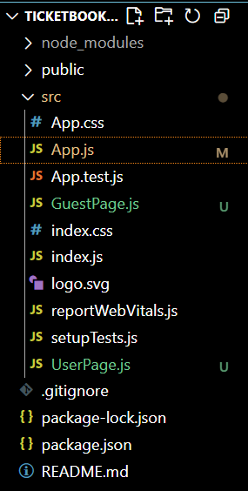

CODE:
App.js
import React, { Component } from 'react';
import GuestPage from './GuestPage';
import UserPage from './UserPage';

class App extends Component {
constructor(props) {
super(props);
this.state = {
isLoggedIn: false
};
}

handleLogin = () => {
this.setState({ isLoggedIn: true });
};

handleLogout = () => {
this.setState({ isLoggedIn: false });
};

render() {
const { isLoggedIn } = this.state;

let content;
if (isLoggedIn) {
content = <UserPage />;
} else {
content = <GuestPage />;
}

return (
<div style={{ padding: '30px', fontFamily: 'Arial' }}>
<h1>✈️ Ticket Booking App</h1>
{isLoggedIn ? (
<button onClick={this.handleLogout}>Logout</button>
) : (
<button onClick={this.handleLogin}>Login</button>
)}
<hr />
{content}
</div>
);
}
}

export default App;

GuestPage.js
import React from 'react';

const GuestPage = () => {
return (
<div>
<h2>Welcome Guest!</h2>
<p>You can browse available flight details below:</p>
<ul>
<li>Flight: AI-203 | Delhi → Mumbai | ₹4500</li>
<li>Flight: SG-502 | Bangalore → Chennai | ₹3500</li>
<li>Flight: 6E-708 | Hyderabad → Kolkata | ₹4200</li>
</ul>
</div>
);
};

export default GuestPage;

UserPage.js
import React from 'react';

const UserPage = () => {
return (
<div>
<h2>Welcome, Logged-in User!</h2>
<p>You can book your flights now.</p>
<form>
<label>Flight ID: </label>
<input type="text" placeholder="e.g., AI-203" />
<br /><br />
<label>Passenger Name: </label>
<input type="text" placeholder="Your name" />
<br /><br />
<button type="submit">Book Ticket</button>
</form>
</div>
);
};

export default UserPage;

OUTPUT:

